**INTRODUCTION - AUDITING**

**MEANING**

The general meaning of audit is an evaluation of a person, organization, system, process, project, or product. Audits are performed to ascertain the validity and reliability of information and to assess a system’s control.

**ORIGIN AND EVOLUTION**

The term audit is derived from the Latin term ‘audire,’ which means to hear. In the early days, an auditor listened to the accounts read over by an accountant to check them. Auditing is as old as accounting.

The objective of audit shifted, and audit was expected to ascertain whether the accounts were true and fair rather than detection of errors and frauds. In India, the companies Act 1913 made audit of company accounts compulsory.

The companies Act.1913 also prescribed for the first time the qualification of auditors The International Accounting Standards Committee and the Accounting Standard board of the Institute of Chartered Accountants of India have developed standard accounting and auditing practices to guide the. accountants and auditors in the day-to-day work.

**DEFINITION**

The term auditing has been defined by different authorities.

1. Spicer and Pegler: "Auditing is such an examination of books of accounts and vouchers of business, as will enable the auditors to satisfy himself that the balance sheet is properly drawn up, so as to give a true and fair view of the state of affairs of the business and that the profit and loss account gives true and fair view of the profit/loss for the financial period, according to the best of information and explanation given to him and as shown by the books; and if not, in what respect he is not satisfied."

2. Prof. L.R.Dicksee. "Auditing is an examination of accounting records undertaken with a view to establish whether they correctly and completely reflect the transactions to which they relate.

3. The book "an introduction to Indian Government accounts and audit" "issued by the Comptroller and Auditor General of India, defines audit “an instrument of financial control. It acts as a safeguard on behalf of the proprietor (whether an individual or group of persons) against extravagance, carelessness or fraud on the part of the proprietor's agents or servants in the realization and utilization of the money or other assets and it ensures on the proprietor's behalf that the accounts maintained truly represent facts and that the expenditure has been incurred with due regularity and propriety. The agency employed for this purpose is called an auditor."

**FEATURES OF AUDITING**

a. Audit is a systematic and scientific examination of the books of accounts of a business;

b. Audit is undertaken by an independent person or body of persons who are duly qualified for the job.

c Audit is a verification of the results shown by the profit and loss account and the situation as shown by the balance sheet.

d. Audit is a critical review of the system of accounting and internal control.

e. Audit is done with the help of vouchers, documents, information, and explanations received from the authorities.

The auditor must satisfy himself with the authenticity of the financial statements and report that they show a true and fair view of the concern's situation.

g. The auditor must inspect, compare, check, review, scrutinize the vouchers supporting the transactions and examine correspondence, minute books of shareholders, directors, Memorandum of Association and Articles of association etc., to establish correctness of the books of accounts.

**OBJECTIVES OF AUDITING**

There are two main objectives of auditing. The primary objective and the secondary or incidental objective.

a. Primary objective – as per Section 227 of the Companies Act 1956, the primary duty (objective) of the auditor is to report to the owners whether the balance sheet gives a true and fair view of the Company’s situation, and the profit and loss A/c gives a correct figure of profit of loss for the financial year.

b. Secondary objective – it is also called the incidental objective as it is incidental to the satisfaction of the main objective. The incidental objective of auditing are:

i. Detection and prevention of Frauds, and

ii. Detection and prevention of Errors.

Elements of Auditing

* Examination by an Independent person
* Nature of Organization
* Detailed verification
* Certain time
* Documents
* Information and Explanation
* Rules and Regulations
* Science and art

**QUALITIES OF AN AUDITOR**

An efficient auditor must have certain qualities besides Professional qualifications. He needs to carry out the audit efficiently and smoothly.

* An auditor needs to be well versed in the fundamental principles and theory of all branches of accounting, e.g., general accounting, cost accounts, income tax, etc. A person cannot audit the accounts unless he knows how to prepare them. He should be aware of the latest development in accounting techniques so that he may modify his work procedure.
* He should not pass a transaction unless he knows that it is correct. This is possible only when one knows thoroughly well the principles of accounting.
* He should be able to quickly grasp the technical details of the business whose accounts he is auditing. If possible, he should pay a visit to the works of his client before he commences his work.
* He should be prepared to seek elucidation on technical questions rather than show a false pride or fear of displaying his ignorance.
* He should be quite familiar with the company and mercantile laws and be a complete master of the principles of auditing.
* He must be tactful and scrupulously honest. He must not certify what he does not believe to be true and take reasonable care and skill before he believes what he certifies is true.
* Others must not directly or indirectly influence him in discharging his duties.
* Sometimes he is put in a very awkward position when his duty to his client is opposed to his interests, in which case he must have the courage to carry out his duty faithfully and honestly, even if such a step harms him. Eventually, this policy will value him. He will acquire a reputation for his honesty, bringing him more business.
* He must be prepared to resign rather than sign a balance sheet, which he knows does not exhibit a true and fair view of the situation of the concern and thus give a false report.
* He should not disclose the secrets of his clients.
* He must have the tact to put intelligent questions to extract full information.
* He must not adopt an attitude of suspicion.
* He must be prepared to hear arguments and must be reasonable.
* He must be vigilant, cautious, methodical, and accurate.
* He should be able to draft the report correctly, concisely, and forcefully.
* He should understand the general principles of economics.
* He should have thorough training in business organization, management, and finance.
* Last but not least, he should have “Common Sense.”

**TYPES OF AUDIT**

## **Internal Audit**

As the name suggests, it is an audit of internal affairs; the Audit is carried out to decide if the internal part of the organization is as per the rules and regulations.

* They [internal Audit](https://www.indiafilings.com/internal-audit) can be done by anyone, even by the organization’s employees.
* In this type of Audit, the auditors check if the organization follows proper norms and rules and whether it complies with all the internal regulatory standards.

## **External Audit**

External Audit can be compulsory for some organizations as per some rules and requirements of shareholders.

* The external audit report shall also be shown to the entire shareholders in annual general and board of directors' meetings.
* Some independent professionals do external Audit with the qualification mentioned in the rule.

External Audits can be done annually, half-yearly or quarterly. If some organizations feel something needs to be correctly visible to seniors, they can also conduct an external audit. The organization can also appoint a third party to conduct an audit.

## **Financial Audit**

Financial Audit is essential for the organization as the shareholder invests money in the business and needs to know if their money is being effectively used. Money is the profit for the company and making a profit is one of the objectives of the business, and it is an income for the organization. Financial Audit is an audit of the books of accounts to know if the organization is expressing the actual books or hiding some facts from their investors.

## **Information Technology Audit**

An information Technology Audit (IT Audit) is carried out to assess the organization’s IT infrastructure and know its system. It is done to inform the stakeholders that the organization’s IT structure is up to date and can meet the goals and objectives.

## **Statutory Audit**

The organization conducts this Statutory Audit to see if the organization is in complying with all Government regulations. It is verified by the external auditor while doing the external Audit and demonstrates some of the financial reports, which include the following:

* Statements of bank
* Number of clients
* Earning on investment
* The Audit improves transparency and trust among all the public and stakeholders of the organization.

## **Performance Audit**

Performance audits cover a variety of assessments. A firm may request a performance audit to evaluate any of the following objectives:

* Program effectiveness and results
* Internal controls
* Compliance with certain requirements
* Prospective analysis
* Operational Audits

Operational audits review an organization’s activities with specific aims. An auditor will analyze the process, procedure, and system; and evaluate operational effectiveness, efficiency, and productivity.

## **Employee Benefit Plan Audits**

An employee benefit plan audit analyzes and evaluates an employee benefit plan’s financial statement.

## **Compliance Audits**

A compliance audit is conducted to determine if it complies with a government’s standards, rules, and requirements. A Government sets the conditions and hires an auditor to evaluate the entity’s compliance.

## **Payroll Audits**

Payroll audits review the payroll processes and reports of a firm. This Audit will identify errors, improve compliance, and protect the company from fraud. An internal auditor or a third-party auditor can perform this Audit.

## **Forensic Audit**

A forensic audit examines a company’s financial records to identify illegal financial activity. The auditor (a forensic accountant) will look for evidence that may be used in court or for conflict resolution among shareholders.

An organization may need a forensic audit if individuals suspect fraud, theft, or inaccuracies (both positive and negative) in account balances.

Interim Audit

An interim audit is performed before the end of a client’s fiscal year and covers the preceding six to nine months. Interim auditing often entails conducting tests of controls and occasionally doing specific substantive processes. While the balance sheet may also be examined, the income statement is the primary focus of this type of assessment.

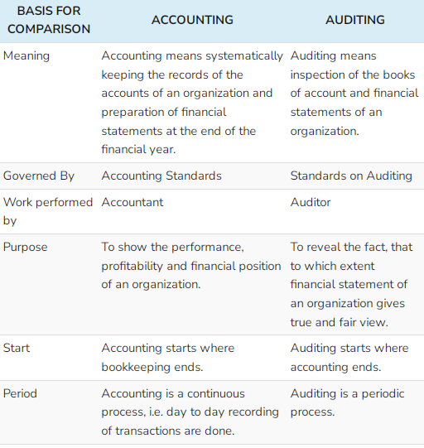

# **Audit planning**

**Audit planning** is a vital area of the [audit], primarily conducted at the beginning of audit process, to ensure that appropriate attention is devoted to critical areas, potential problems are promptly identified, work is completed expeditiously, and work is properly coordinated. "Audit planning" means developing a general strategy and a detailed approach for the expected nature, timing, and extent of the audit. The auditor plans to perform the audit in an efficient and timely manner. In simple words, developing an overall strategy for the effective conduct and scope of the examination.[[1]](https://en.wikipedia.org/wiki/Audit_plan#cite_note-1)

It addresses the specifics of what, where, who, when and how:

* What are the audit objectives?
* Where will the audit be done? (i.e., scope)
* When will the audit occur? (how long?)
* Who are the auditors?
* How will the audit be done?

**Process of audit planning**

It includes following procedures

* Knowledge of client's business, which includes financing, legal framework, government norms, investments, accounting policies, business risk and financial risk
* Development of audit strategies or overall plan (who, when and how)
* Preparation of audit programme

### **DEFINITION OF AUDIT PLAN/PROGRAMME**

**Prof. Meigs** defines an audit programme as,“an audit programme is a detailed plan of the auditing work to be performed, specifying the procedures to be followed in verification of each item and the financial statements and giving the estimated time required.”

An **audit plan** is the specific guideline to be followed when conducting an audit.[[2]](https://en.wikipedia.org/wiki/Audit_plan#cite_note-2) It helps the auditor obtain sufficient appropriate evidence for the circumstances, helps keep audit costs at a reasonable level, and helps avoid misunderstandings with the client. Audit planning includes establishing the overall strategy for the audit engagement, with a particular focus on planned risk assessment procedures and responses to the identified risks of material misstatement.[[3]](https://en.wikipedia.org/wiki/Audit_plan#cite_note-3)

Features (or) Characteristics of an Audit Programme

The features of an audit programme may be of the following:

1. It is a set of procedures to be adopted to conduct the audit more efficiently.

2. It is a written scheme designed by the auditor.

3. It is a blueprint of the audit work.

4. It facilitates delegation of work, based on the capabilities of audit staff.

5. It acts as evidence in future for the audit work being performed.

6. It specifies the work to be done by the audit staff, the manner and time limit for completion of the work.

**Objectives of Audit Programme**

The following are the objectives of audit programme:

1. To provide clear instructions to the audit assistants specifying the nature of the work to be performed and fixing the time span for completion of each work.

2. To facilitate coordination among various parts of audit work.

3. To ensure uniformity in the performance of audit work and to avoid duplication and repetition of work.

4. To attain a fair allocation of work among the audit team.

5. To fix responsibility and accountability of each audit assistant.

6. To serve as a guide for planning the audit work in future.

7. To serve as evidence in future showing the date of completion of audit work, methods or procedures undertaken, persons involved in completion of audit work etc.

**Contents of an Audit Programme**

The following are the details of an audit programme:

1. Name of the client.

2. Nature of operations and business of client.

3. Review of system of internal check.

4. Date of commencement of audit work.

5. Duration of audit work.

6. Accounting system followed in client organization.

7. Review the report of the earlier auditor.

8. Review the remarks, instructions or objections raised in the earlier audit report.

9. Examine the various ledger accounts and subsidiary books.

10. Examine the statutory books and registers, profit and loss account, and balance sheet.

**Advantages of an Audit Programme**

An audit programme can give the following advantages:

1. Helps in Estimation and Division of Work: Audit Programme helps in estimating the quantum of audit work in advance and also helps in dividing the work among the audit assistants based on their capabilities.

2. Helps in Fixation of Responsibility: It enables us to fix responsibility on the audit assistants by clearly defining the scope of work.

3. Helps in Future Planning: Audit programme serves as a basis for planning the audit work for the subsequent year.

4. Serves as a Guide: It serves as a valuable guide for the audit staff in execution of the audit work for succeeding years.

5. Valuable Evidence: It serves as evidence for the work done as initials of those who have done the work are appended to it. The auditor can produce the audit programme as proof when a charge of negligence being brought upon him.

6. Uniformity: It provides for uniformity in audit work as the same work will be done every year.

7. Continuity: When an audit staff member goes on leave others can continue the work by referring to the audit programme, hence, the audit programme provides for continuity of work.

8. Coordination: If eases coordination and helps in supervising the work of the audit staff.

**Disadvantages of an Audit Programme**

The disadvantages that may be experienced by conducting audit as per predetermined audit programme are -

**1. Mechanical:** When audit work is conducted mechanically every year based on the audit programme, it causes monotony and boredom to the auditor and audit staffs.

**2. No Quality in Work:** The audit staff will be more interested in completing the work on time rather than keeping any standard in the work.

**3. Loss of Initiative:** Audit staff cannot take their own decisions and they are compelled to follow the audit programme. Hence, an efficient audit clerk loses his initiative and interest as he cannot make any suggestions.

**4. Rigidity:** A rigid and inflexible audit programme cannot be laid for all types of business. During the audit, new areas to be verified may be notified by the audit staff. Unless the audit programme is revised, such areas may escape from auditing.

**5. Shelter for Inefficient Staff**: Inefficient audit staffs conceal their mistakes or weakness on the basis of audit programme. Hence, it provides shelter for inefficient audit staff.

**6**. **Unsuitable**: Pre-determined audit programme is not suitable for small business organizations.

**Process of Audit**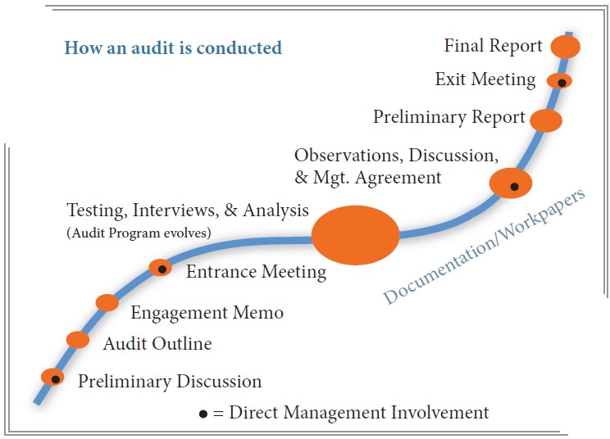

**Specimen of Audit Programme** 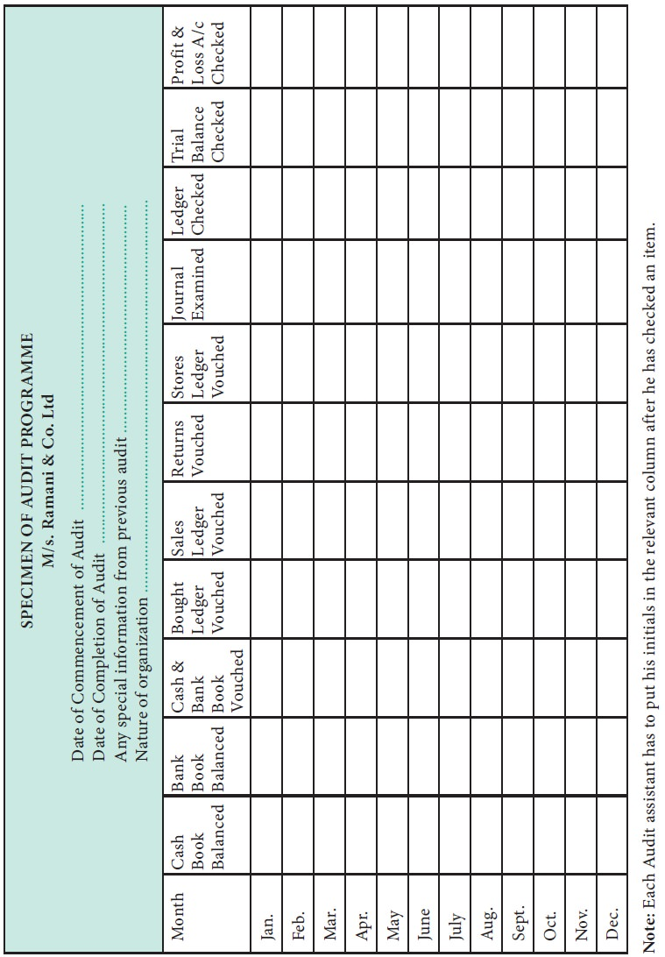

**Auditor is a watchdog, not a bloodhound.**

## **The statement implies:**

An auditor is appointed by the shareholders in the case of a limited company. He is expected to play the role of a watchdog on their behalf and should look after their interests.

Unlike a bloodhound the duty of the auditor is verification and not detection. If he discovers something suspicious, during the audit, he should probe the matter thoroughly and appraise the shareholders about it. In the absence of such suspicious circumstances, he is fully justified in believing and relying on representations made by the ‘tried servants’ of the company. In short, in case of frauds and errors, the auditor has a duty of ‘reasonable care only.

**Meaning of Audit Notebook**

Audit Notebook is a diary for auditors to record observations, errors, doubtful queries, explanations, and clarifications to be received from the clients.

The audit notebook is a register maintained by the audit staff to record important points observed, errors, doubtful queries, explanations, and clarifications to be received from the clients.

Mostly the audit notebook contains information regarding day-to-day work performed by the audit staff on any particular date.

Notes about all types of errors, difficulties, and uncleared queries or points to be discussed with the auditor or clients and the points to be incorporated in the report are noted.

An audit notebook is a diary on which auditors scribble down all crucial inquiries to avoid the possibility of unquestioned material facts.

**Contents of Audit Notebook**

An audit notebook is a diary for auditors to record all crucial inquiries, observations, explanations, errors, and clarifications to avoid the possibility of unquestioned material facts. Some of the points which are noted down in an Audit Notebook are given below:

**General Information**

* The nature of the business carried on and the important documents relating to the constitution of the business.
* The name of the client and the audit year.
* A list of books of accounts in use.
* Names of principal officers, their duties, and responsibilities.
* Particulars of the accounting and financial system followed and the internal check-in operation in the business.
* Details regarding accounting and financial policies followed in the business.
* A copy of the audit program.
* The technical terms used in the business.
* Notes and queries which might be required at a subsequent audit.
* The accounting method is followed in the business.
* Special Matters to be recorded in the Audit Notebook
* Routine queries not cleared, i.e., missing receipts and vouchers, etc.
* Details of mistakes and errors discovered.
* The points raised during an audit to which the auditor’s attention must be drawn, i.e., the company’s failure to comply with the provisions of the Companies Act or the Memorandum of Association and other legal requirements.
* Extracts from minutes, books and contracts, and correspondence with various government agencies, financial institutions, debtors, creditors, etc.
* The points to be incorporated into the audit report.
* The points which need further explanation and clarification, e.g., a change in the basis of valuation of finished stocks or the computation of depreciation, etc.
* Date of commencement and completion of the audit.

**Advantages of Audit Notebook**

The audit notebook helps the auditor to prepare an audit report. A separate audit notebook is maintained for each concern.

Advantages of an audit notebook are;

* Audit Report
* Staff Honesty
* Helpful for Memory
* Reference
* New Auditor
* Court Cases
* Audit Report

The audit notebook helps prepare an audit report. The auditor can record the weakness of accounting records. The queries not properly answered are started in the audit report.

When the auditor is satisfied, he can submit a clear report.

**Staff Honesty**

The audit notebook is used to determine the integrity and honesty of audit clerks. The moral and ethical values can be examined through audit work.

When a person Completes his work in time, an auditor can appreciate him. If there is pending work after the expiry of the period, he can be held responsible for it.

The audit staff must be honest in their work.

**Helpful for Memory**

The audit notebook helps to keep things fresh in memory. The auditor can read the book daily. He can note the weakness in his fingertips. The auditor can retain the data in his memory for a longer period.

He can ask the management to clear the doubtful points before preparing an audit report.

**Reference**

The audit notebook is useful for reference.

In the future, it can provide information to the audit staff. The past data gives an insight into business matters. The auditor can note the changes.

He can form an opinion about the changes in the nature and size of the business.

**New Auditor**

The audit notebook is useful for a new auditor. They can see the weakness of previous years. The old weak points may not be repeated this year.

**Court Cases**

The audit notebook helps defend an auditor in court cases. The people can go to the court of law to fix liability for the negligence of duty. The audit notebook is written proof of work performed by an auditor.

**Routine Checking**

Regular checking of all the daily transactions is known as Routine Checking. Routine checking incorporates the following tasks:

* Checking of record in primary books, costing, transfer etc.
* Checking transfer of transactions from original books of accounts to ledger account.
* Checking debit and credit side of various accounts.
* Checking transfer of balances of various accounts to other pages or accounts or statements.
* Various signs are used while conducting routine check. Such signs provides the proof of routine checking of transactions. Signs which are used in audit should be small and clear. Generally red or pink colour is used while conducting routine checks. But green color is used while conducting final audit.

**Advantages Of Routine Checking**

Following benefits can be obtained from the routine checking:

1. All the original entries will be checked; so, all the errors and frauds can be detected easily.

2. All the entries and posting will be tested.

3. Routine checking helps to conduct final audits because all the balancing and totals have already been checked.

4. Separate and specific staff are not needed because it is a regular process.

**Disadvantages Of Routine Checking**

Followings are the limitations of routine checking:

1. Routine checking is a mechanical test, so the staff who performs this work does not have inspiration. So, there are chances of leaving errors and frauds.

2. Routine checking can only detect small errors and frauds but not the planned frauds.

3. Routine checking is not needed where self-balancing system is applied.

4. Routine checking cannot detect principle and compensating errors

**Test Checking**

* Test checking in Audit means checking a few transactions selected at random from a large number of transactions. It is also known as “Selective Verification” or “Sampling Process “.
* It is a substitute for detailed checking. It involves only a partial check.
* It is based on a simple theme that if a representative number of transactions, randomly selected by the auditor for test checking is found to be correct, the rest might be correct too. In simple words in test checking a representative number of entries of each class is selected and checked and, if they are found correct, the remaining entries are also taken to be correct.
* Test checking is an accepted substitute of detailed checking, which in most cases from the economic point of view is unwarranted.
* Adoption of test checking methods by auditors the decision to adopt testing methods depends entirely on the auditor’s judgement and discretion depending on the individual cases and circumstances.
* Test checking should be applied and carried out intelligently and carefully; otherwise, it may lead to dangerous consequences.
* However, the use of test checking depends much upon the system of internal check in operation and the intelligence of the auditor.

Safeguards for the Application of Test Checking While applying test checks the auditor should take the following precautions:

1. As far as possible sample transactions should be selected from every book.

2. The selection of transactions should be so distributed that the work of almost all the clerks of the client is checked.

3. The items should be selected at random.

4. As fraudulent manipulations are common during the first and last months of the period under audit, the entries made during these periods should be checked thoroughly.

5. In the selection of entries and accounts for applying test checks, care should be taken to check the different portions of the work at each audit.

6. Cash book and passbook should be checked thoroughly.

7. The auditor should select the transactions on his own. He should not consult the staff of the client while selecting the transactions. If the auditor exercises the above safeguards with care and caution, the results are bound to be encouraging and satisfactory.

**Advantages of Test Checking**

Test checking enjoys the following advantages:

1. It saves time and energy.

2. If the selection of transactions is done intelligently, test checking is useful and purposeful.

3. The volume of work is reduced. So, the auditor can carry out many audits simultaneously.

4. It helps the auditor to arrive at a definite conclusion regarding the true and fair view of the state of affairs of the concern.

5. It helps in reducing the cost of audits.

**Disadvantages of Test Checking**

Test checking suffers from the following disadvantages:

1. It is not possible to detect all the errors and fraud.

2. The clerks of the client may become careless because they know that their work will not be checked in detail.

3. Under test checking, although the auditor checks the whole of the work through test checking, suspicion and doubt will remain in his mind.

4. It is of no use if proper and effective systems of internal checks and controls are not being adopted in business.

5. It is not suitable for small business concerns.